JavaScript TraceTool API Documentation

Introduction 2
Tracetool client configuration 2
Samples use 3
API documentation overview 9
ttrace 10
ttrace.options 10
ttrace.classes.TraceToSend 10
ttrace.classes.TraceNode 10
ttrace.classes.TraceNodeEx 11
ttrace.classes.MemberNode 11
ttrace.classes.WinTrace 12
ttrace.classes.WinWatch 12
ttrace.classes.TraceTable 12

Introduction

The tracetool for JavaScript is a cross browser and cross domain tracing solution.

License information: You are free to distribute the viewer (GPL) and to incorporate the library (LGPL) in your product (commercial or not). The only thing you can't do is to sell the viewer (or a modified version) and the API as a tracing solution.

Six frameworks are currently supported: Dot net (C#), Java , JavaScript, Delphi for window , C++ and ActiveX
Since theses languages are different, the syntax and the options are a little bit different.

C#: TTrace.Warning.Send ("Hello");
Java: TTrace.warning ().send ("hello");
Delphi: TTrace.Warning.Send ('hello');
C++: TTrace::Warning ()->Send ("Hello");
Javascript : ttrace.warning().send(“Hello”);
ActiveX : Depends from the host (script , VB, …)
See the corresponding TraceTool API documentation’s for more details on theses languages.

The entry point of the framework is the ttrace class.
That class provide 3 invisible parents node (Debug, Warning and Error) with specific icon and with the “enabled” property set to true.
ttrace has some global functions, like clearAll () to clear all the traces and show () to show or hide the viewer

The framework gives the possibility to create multiple Tab traces, see the WinTrace class.

TraceTool propose 2 ways to send traces:
- TraceToSend
- TraceNodeEx

In TraceNode mode, traces are sent from a Parent node. (debug, warning and error)
It’s the quicker way to send normal traces.

The problem with TraceToSend is that this class cannot provide hundreds of overload methods to match the developer needs.
For example Send (“Col1”, “Col2”, Type) or Send (“col1”, IconIndex) .
It’s where TraceNodeEx is needed.
In this mode, TraceNodeEx is created first, filled by the developer and then sent.
Using TraceNodeEx, you can specify left and right column separately, give an icon and add some information onto the “member” pane, like dumps, class type, object or stack information on a single trace. The constructor has one parameter: TraceToSend’s parent Node. If supplied, the trace is added under the ParentNode and receives the same IconIndex and Enabled properties.

JavaScript compatibility

The tracetool API was tested with Firefox 2, IE 7 and opera Mobile.

Tracetool configuration

1) First at all, you must start the viewer and configure the port

Menu View/Options…
Then chose the ‘Framework’ item and look at the “HTTP port”. Specify an empty port (like 81).
Ideally don’t use 80 to discard web server collision. The default value is 0. That means that the viewer don’t listen for http requests.
Put the tracetool.js and tracetool.jmin.js files at the same place as the viewer.

2) Configure the web page :

The best way to load the library is ask the viewer to send the script. Add this line on the body tag :
<script type="text/javascript" src=" http://localHost:81/tracetool.js?Compressed=true" no-cache></script>
In the “src” attribute, specify the viewer address and the port (same as the viewer http port).
The optional ‘Compressed’ query string specify the compression (true/false). Default is false.
The non compressed version is more or less 117K and the compressed version is 38K

You can also put the tracetool.js on your web server and add this line on the body tag :
<script type="text/javascript" src="tracetool.js" no-cache></script>
This is not the ideal way to load the API : The default destination is set to "127.0.0.1:81" and traces manipulations (resend, add , delete) can interfere with other JavaScript clients.
To change viewer address and receive an unique API id, use theses commands before sending traces:
ttrace.setHost("localHost:81"); // or any other address/port
ttrace.queryClientId() ;

Samples use

Simple traces

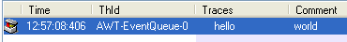

Using TraceToSend/TraceNode

ttrace.debug().send('hello world') ;
ttrace.debug().send('hello','world') ;

Note that the icon is the same as debug() node.
To specify icon, use TracenodeEx.

Using TraceNodeEx

var nodeEx = new ttrace.classes.TraceNodeEx (ttrace.debug()) ; // parameters : parentNode, generateUniqueId
nodeEx.leftMsg = 'TraceNodeEx' ;
nodeEx.rightMsg = 'Sample' ;
nodeEx.send() ;

Hierarchical traces

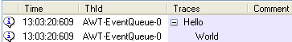

Using TraceToSend/TraceNode

var hello = ttrace.debug().send('hello') ;
hello.send('world') ; // send traces under another node

Or in a single line :

ttrace.debug().send('hello') .send('world') ; // send traces under another node

Using TraceNodeEx

var node1 = new ttrace.classes.TraceNodeEx (ttrace.debug()) ;
node1.leftMsg = “hello” ;
node1.send () ;

var node2 = new ttrace.classes.TraceNodeEx (node1) ;
node2.leftMsg = “world” ;
node2.send () ;

Hierarchical traces using Ident and UnIndent

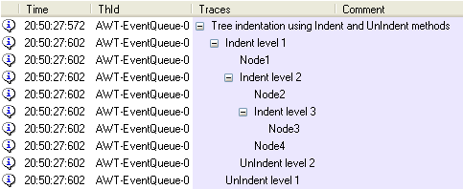

The ident function add a message to the specified node.
Further sendxxx methods to this node will be added under the message.
unIndent with or without a message return to previous level.
This can be used for call stack tracing or loop traces.
Indent can be used on a specific node or one of the root (debug, warning, error)

Using TraceToSend/TraceNode

var node = ttrace.debug().send("Tree indentation using Indent and UnIndent methods ") ;

node.indent("Indent level 1") ;
node.send ("Node1") ;
node.indent("Indent level 2") ;
node.send ("Node2") ;

// UnIndent with no title
node.indent ("Indent level 3") ;
node.send ("Node3") ;
node.unIndent () ; // UnIndent without title

node.send ("Node4") ;

node.unIndent ("UnIndent level 2") ;
node.unIndent ("UnIndent level 1") ;

Overrides traces

Use one of the resendXXX or appendXXX to modify existing text node

Using TraceToSend/TraceNode

var appendNode = ttrace.warning().send("Start 1 ..") ;
// do some work …
appendNode.appendLeft("Done") ;

// Same for other resendXXX and appendXXX function

Using TraceNodeEx

var node1 = new ttrace.classes.TraceNodeEx (ttrace. debug()) ;
node1.leftMsg = Start 1 ..” ;
node1.send () ;
// do some work …
node1.rightMsg = “done” ;
node1.resend() ;

// no append functions, you must resend the whole text.

Objects information

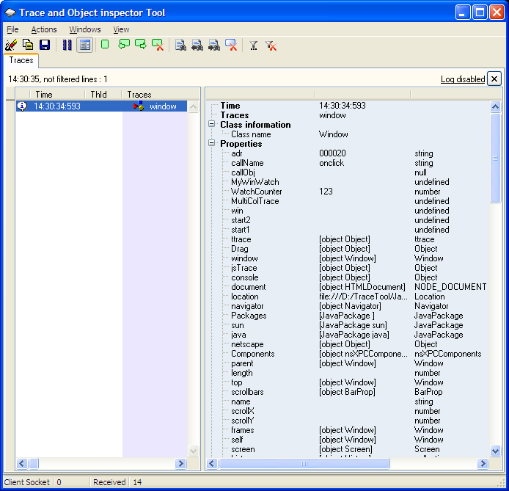

Using TraceToSend/TraceNode

ttrace.debug().sendObject ("window" , window);

Using TraceNodeEx

var node1 = new ttrace.classes.TraceNodeEx (ttrace.debug()) ;
node1.leftMsg = “window” ;
node1.addObject (window);
node1.send () ;

Objects value

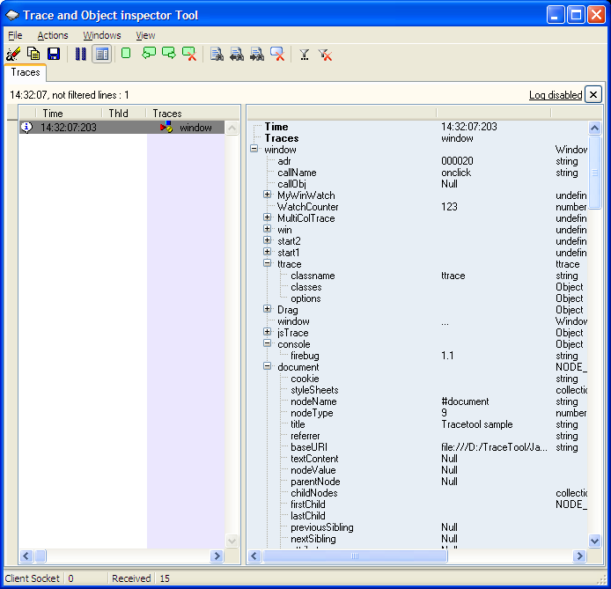

Using TraceToSend/TraceNode

ttrace.debug().sendValue(“window”, window);

Using TraceNodeEx

TraceNodeEx node1 = new ttrace.classes.TraceNodeEx (ttrace.debug()) ;
node1.leftMsg = “window” ;
node1.addValue (window);
node1.send () ;

Dump

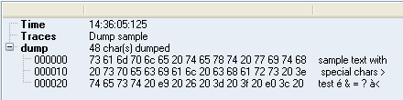

Using TraceToSend/TraceNode

ttrace.debug().sendDump("Dump sample", "dump", "sample text with special chars >test é & = ? à< ") ; // , 30

Using TraceNodeEx

var node1 = new ttrace.classes.TraceNodeEx (ttrace.debug()) ;
node1.addDump("dump " , "sample text with special chars >test é & = ? à< ") ; // , 30
node1.Send () ;

Stack information

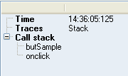

Using TraceToSend/TraceNode

ttrace.debug().sendStack ("Stack test" , 0) ;

Using TraceNodeEx

TraceNodeEx node1 = new ttrace.classes.TraceNodeEx (ttrace.debug()) ;
node1.leftMsg = "stack" ;
node1.addStackTrace () ;
node1.send () ;

Caller information

It’s like the stack information, but displays only the first line. Caller display the first line of Stack

See the help file for other kind of traces, like Table and XML.
Multi Column support

The original framework allows you to send 2 columns of information (including thread name, icon and date).
Since the Log4J/Log4Net support, it’s now possible to send as many columns of data as you want, but with a small restriction:
Multi column is not supported in the main trace window, since many applications (and in different languages) cannot share the main window in “classic” mode and in “multi column” mode.

You must then create a window trace and set the titles. (with just a few lines)

In that mode, of course, you have to send yourself the thread name and date if you need it.

Sending many columns of text is performed with the same API as for simple trace.
Just add a tabulation (“\t”) between the different columns.

Here is an example :

var MultiColTrace ;
function butMulticolTest()
{
MultiColTrace = new ttrace.classes.WinTrace("MCOL", "MultiCol trace window");
MultiColTrace.setMultiColumn(1); // must be called before calling setColumnsTitle
MultiColTrace.setColumnsTitle("col1 \t col2 \t col3");
MultiColTrace.setColumnsWidth("100:20:80 \t 200:50 \t 100");
MultiColTrace.displayWin();
MultiColTrace.debug().send("1 \t 2 \t 3");
}

See the help for WinTrace documentation.

API documentation overview

The framework defines a lot of public classes, but you need to learn only the TraceToSend class for to the majority of the traces.
Traces can be done in 1 line of code :
ttrace.warning ().sendValue ("My Object", myObject);

The following diagram exposes the public classes. See the help file for full API documentation.

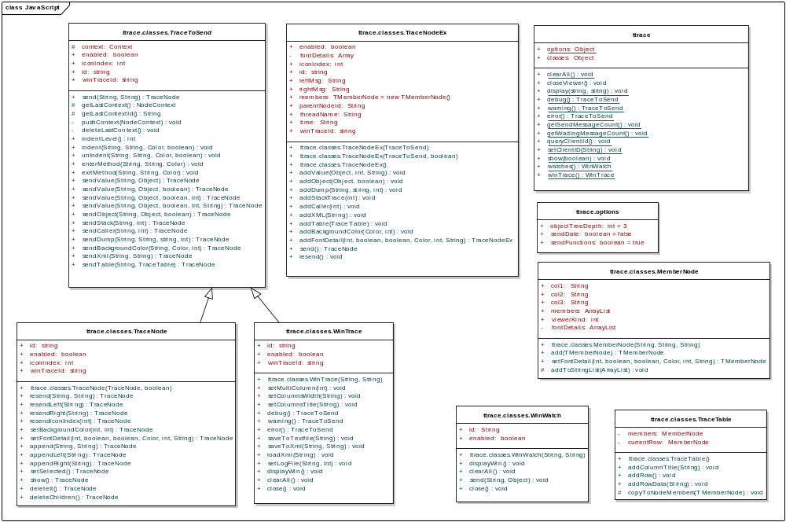

ttrace

ttrace is the entry point for all traces.He gives 3 'TraceToSend' doors: warning(), error() and debug().
Theses 3 doors are displayed with a special icon. All of them have the 'enabled' property set to true.
You can set it to false to limit logging. That class is fully static.

ttrace represent also the viewer:
- Clear messages on the main window.
- Show / hide / close the viewer.
- Give access to the main trace window, the main watch window
- Give access to the main debug, warning and error node.

ttrace.options

Options for the traces, accessible from ttrace.Options:
- Indicate if the date must be send.
- Indicate if the reflection should display functions .
- Number of level to display for the sendValue and addValue functions

ttrace.classes.TraceToSend

This class is abstract. You don’t have to create a descendant class or object yourself.
The API provides predefined TraceToSend objects and some ways to create TraceToSend objects.
The ttrace.debug() , warning() and errors() object for example are TraceToSend descendant objects you can use :

ttrace.Debug.Send (“Hello”, “World”) ;

TraceToSend inherit from TraceNodeBase:
- Trace id
- Enabled flag
- Index of the icon to use.
- The window where trace is send.
- User variable (Tag) , provided for the convenience of developers

TraceToSend allow you to send :
- Simple messages (1 or 2 columns).
- Indented messages (see Indent, UnIndent, EnterMethod and ExitMethod).
- Objects information and object values
- Stack information
- Dump
- Tables
- Xml.

All methods of this class send traces and return a TraceNode object.

ttrace.classes.TraceNode

TraceNode object represent a node already send on the viewer. You can :
- Resend left and/or right message to the viewer
- Append text to the left and/or right
- Show or select the node
- Delete the node or delete children node
- Change font detail

ttrace.classes.TraceNodeEx

Alternate ways to send traces: prepare a TraceNodeEx with all properties and then send it.
The main difference between TraceNodeEx.addXXX method and TraceToSend.sendXXX method is that sendXXX creates a new child trace that is directly send.

You can call many addXXX on a TraceNodeEx object and then send it.

TraceNodeEx define:
- Trace id
- Enabled flag
- Index of the icon to use.
- The window where trace is send.
- Left message , right message,
- Parent node id
- Message Time
- Message Tread name
- Members (information panel). See MemberNode class
- Function to add Object information
- Stack information
- Dump
- Tables and string list
- Xml.
- A “send” method that send the trace to the viewer
- A “resend” method that resend the left and right message.

The send method returns a TraceNode object.

ttrace.classes.MemberNode

MemberNode represent a node information in the "info" trace tree.
Use one of the AddXXX methods to create members or use MemberNode constructors then add to members

Sample code :

var nodeEx = new ttrace.classes.TraceNodeEx (ttrace.debug()) ;
nodeEx.leftMsg = 'TraceNodeEx' ;
nodeEx.rightMsg = 'Sample' ;
nodeEx.members.add('my member', 'col2') ;
nodeEx.send() ;

ttrace.classes.WinTrace

Represent a trace window in the viewer. The main trace window is accessible from the ttrace.WinTrace property.
To create a new WinTrace, call the constructor with a user defined WinTraceID and a title.

WinTrace objects let you manage traces in that window :
- Clear messages
- Set log file
- Save to text or xml files
- Load from xml files
- Change columns
- Interact with the viewer actions using the plugin API (See The plugin chapter.)

Sample code :
// create a new window
var win ;
win = new ttrace.classes.WinTrace("MyWinTrace","MyWinTrace") ; // parameters : WinTrace Id and Text

// send traces to a specific window
win.debug().send('my trace') ;

Note: Wintrace derive from TraceToSend, with the IconIndex set to debug.
That means that you don’t need to use the debug() entry to send debug traces:

win.send (“hello”)

// save all the traces to XML
win.saveToXml (“MyException.xml”) ;

Note : the main page is also a WinTrace object. To save all messages use the following command :
ttrace.winTrace().saveToXml (“Main traces.xml”) ; // path is relative to the viewer location, not your application.

ttrace.classes.WinWatch

WinWatch represent a window where you put watches.

The ttrace.watches() method give access to the main Watch window.
To create a new window watches, call the constructor with a user defined Id and a title.

Watches are languages independents: you can send a Dot Net Watch to the viewer that can be changed by a Java application.
Watches are displayed in a tree (fields and sub objects).

The number of objects displayed by recursion is dependent of the objectTreeDepth option variable.

Samples :

// Clear the main watch window, send a watch then ensure the main watch window is displayed

ttrace.watches().clearAll() ;
ttrace.watches().send("test2", mySet); // mySet can be any object, like an HashSet
ttrace.watches().displayWin() ;

// Create a new WinWatch window and send watches. The watch window can be displayed with the displayWin() method

var MyWinWatch;
MyWinWatch = new ttrace.classes.WinWatch("MyWinWatchID", "My watches");
MyWinWatch.send('ttrace', ttrace);

ttrace.classes.TraceTable

Construct a table of row to display in the viewer on a node.
The table must be associated with a node.
See TraceNodeEx.AddTable() and TraceToSend.SendTable()

